Canadian Feedlot Animal Care Assessment Program
This document contains generic templates for protocols in the Canadian Feedlot Animal Care Assessment Program that can be used by feedlot producers who do not have their own written protocols. These protocols can be modified to fit a feedlot’s current management procedures. Protocols should be dated and signed by the responsible person and be reviewed annually and updated as procedures changed.
- Animal Care Policy
- Emergency Response Plan (includes animals in transit)
- Incoming Protocol for Handling Sick, Injured, Fatigued or Immobile (non-ambulatory) Cattle on Truck
- Pen Maintenance Plan or Records for Manure Management
- Training Program and Related Records for Low Stress Cattle Handling, Feeding, and Animal Health
- Protocol to Handle Compromised (Non-ambulatory Cattle and Seriously Injured) Cattle
- Feeding Protocol and Related Records – contact your feedlot nutritionist to develop and monitor
- Processing, Reimplant, and Treatment Protocols and Related Records – contact your feedlot veterinarian to develop and monitor
- Surgical Procedures Protocol – contact your feedlot veterinarian to develop, if feedlot staff perform surgical procedures at the feedlot (e.g., prolapse repair, spay heifers)
- Castration Protocol – must include pain control
- Dehorning Protocol – must include pain control
- Branding Protocol
- Euthanasia Protocol
- Emergency Salvage Slaughter Protocol (if applicable)
- Antimicrobial Stewardship Policy/Protocol
- Broken Needle Protocol
- Shipping Protocol and Shipping Record Example
- Abortion Protocol
- Biosecurity Protocol and Visitor Log
- Cattle Health Product Management Protocol
- Calving Management Protocol
- Newborn Calf Management Protocol
- Carcass Disposal Protocol
- Chronic Pen and Railer Protocol

- Animal Care Policy

We at ______________________feedlot, are committed to ensuring the well-being of all the cattle in our feedlot. We implement the requirements in the Canadian Beef Code of Practice. We ensure that the cattle under our care are raised in a safe environment that meets their physical, nutritional, health, and welfare requirements. We work with our veterinarian and nutritionist to train and monitor our staff to ensure continuous improvements in our animal husbandry, beef quality, and production management practices whilst ensuring beef safety. We use trained livestock truckers, such as Canadian Livestock Transport Certification Program (CLT) or Beef Quality Assurance Transportation (BQAT), and we follow CFIA federal transportation regulations.

______________________________________ ___________________
Feedlot Owner/Manager’s Signature Date

------------------------------------------------------- ANOTHER EXAMPLE ---------------------------------------------

Animal Care Policy

We care for our cattle as per the Canadian Code of Practice for Beef Cattle and ensure safe and high-quality beef production.

______________________________________ ___________________
Feedlot Owner/Manager’s Signature Date

- Emergency Response Plan

Feedlot Name: __________________________ Owner: _________________________________
Premise ID: _____________________________ Land Location: ___________________________
Municipal Address: _______________________________________________________________
Phone #: _______________________________ Fax #: __________________________________
Current Emergency Phone Contact List (attached) is posted in:
- Office
- Process and treat barn
- Feed truck scale room
- Feed mill
- Other: _____________________________________________________________________.
A map of the feedlot is located in: ______________________________________________________.
The following key feedlot personnel are trained and current in emergency first aid and CPR:
Name Phone #
_______________________________ ___________________________
_______________________________ ___________________________
_______________________________ ___________________________
_______________________________ ___________________________
First aid box is located in: ______________________________________________________________.
Personnel responsible for maintaining supplies in first aid box: ________________________________.
In the event of a human medical emergency, the procedure is:
- Call #911 immediately.
- Call feedlot foreman/assistant foreman immediately.
- Call feedlot person trained in first aid and CPR above if different than feedlot foreman.
- Follow the instructions of that trained person.
- If human medical emergency related to accidental administration of animal health products to person, call feedlot veterinarian.
- Assist EMT/paramedics as per their instructions.
In the event of an animal medical emergency, the procedure is:
- Call feedlot foreman or assistant foreman immediately.
- Feedlot foreman/assistant foreman call feedlot veterinarian.
- Follow feedlot veterinarian’s animal health protocols or phone instructions of feedlot veterinarian.
In the event of a livestock transport emergency, the procedure is:
- Call #911 for fire department and police. If human injuries, also call for ambulance.
  - Give location of the accident.
  - Tell them if there are human injuries.
  - Tell them how many animals are on board and the status of any loose animals.
  - Tell them of any known hazards – other vehicles, downed power lines, fires, loose/injured animals.
  - Tell them how many vehicles are involved.
- Set out emergency warning devices within 10 minutes of accident.
- Call truck dispatch and note any response the company may be sending to the scene, such as sending another truck to pick up live animals.
- Call feedlot owner of animals. Feedlot owner should call the packer/processor if fed cattle were on the way to the plant to get their response on situation.
  - Note: once the incident has occurred, the truck and its contents become the property of the insurance company and are no longer the property of the trucking company or the livestock producer. Follow the instructions of the insurance company or assist them in deciding how to manage the remaining live animals.
- Follow the instructions of the incident commander (IC) – this is the first responder (police, EMT, fire) on the scene who is in charge of the incident. Typically, the incident commander is law enforcement/peace officers. Assist first responders with information regarding the livestock, their condition, the layout and equipment in/on the hauler, names of local large animal veterinarians in area of accident, names of local brand inspectors, if AFAC livestock emergency trailer available in area, how to contact them.
- Assistance could also include:
  - If requested by law enforcement, you and a brand inspector may assist in euthanizing animals and providing the appropriate firearms (.22 magnum or shotgun). Be aware of human safety if you are helping to euthanize distressed animals on truck.
  - Finding portable gates from local farmers if possible, to temporarily house live offloaded cattle or finding local rancher/feedlot with horses/pen riders to move cattle to a safe location or providing pen riders/horses from feedlot to move animals if accident close to feedlot.
  - Finding another truck to transport live animals (transport company involved in incident should do this).
  - Moving live cattle to closest facility, such as a ranch, feedlot or auction market for further inspection and treatment by a veterinarian. Ensure these cattle have access to feed and water and bedding on their next location.
  - Calling rendering to pick up dead animals.
  - If animals are injured, identifying and calling a local large animal veterinarian on how to treat injured/distressed cattle. Note: if accident occurs near feedlot, call feedlot veterinarian for assistance.
  - Should live cattle be transported back to the feedlot following a truck rollover, call the feedlot veterinarian to examine cattle to see how these animals need to be treated and to assess the animals to see if additional animals need to be salvage slaughtered or euthanized.
- Ensure all livestock trucks have a SRM permit.
In the event of a fire, the procedure is:
- Call feedlot foreman/assistant foreman immediately.
- Call #911 if fire cannot be easily and safely contained by feedlot personnel. Call County office for help as well if large grass fire.
- Ensure feedlot staff and animals are safe.
  - Move animals or staff if necessary, for safety.
    - If entire feedlot at risk of wildfire, contact feedlot owner and talk to fire department chief as to best practice. One should only open gates of all pens if cattle can be moved ideally into another contained area e.g., field across the road with fencing, if such movement doesn’t put people or vehicular traffic at risk. If cattle cannot be moved into a contained area and feedlot is at serious risk of burning down and people are not at risk, open the gates and turn cattle loose to take their chances with the fire. Collect cattle after the fire. Contact feedlot veterinarian to deal with any distressed burned cattle. Humanely euthanize those severely burned immediately.
    - If fire on an individual animal due to application of electric prod where ivermectin drenched on back, use blankets or water to eliminate fire on animal. Call feedlot veterinarian immediately on treatment for animal. Re-instruct staff on proper use of prods.
  - If office at risk of fire, ensure back-up tapes of health software and other office data are removed (note: back-up tapes should be made nightly and stored off site or in fire and waterproof room or safe).
- Get fire extinguishers and eliminate the fire if you can do so safely.
  - Ensure fire extinguishers are located in the office, coffee room/kitchen, barn, shop, feed mill, and each feed truck.
  - Fire extinguishers are located: _______________________________________________________________________________________________________________________________________________.
  - Personnel responsible for ensuring fire extinguishers are recharged annually or after use: ___________________________________________________________________.
- If larger fire, get water truck and hoses to help extinguish fire if you can do so safely. Water fences or roofs of buildings if fire getting close to buildings and pens. Water down hay and straw stacks as well.
- Remove sources of fuel and move all hazardous materials out of way of fire if possible.
- If fire is in a field getting close to the feedlot, get farm tractors with cultivators or plows and break up land around feedlot to keep fire from getting into feedlot. Break up land at least 20 meters around pens/buildings.
- Call neighbours for help.
- Clean up after fire and review to see what could have been done to prevent fire or better manage fire.
Prevention of fire:
- Keep areas around all barns and building free of brush, debris and machinery.
- Ensure hay and straw stacks and silos are surrounded with a bare area – at least 5 meters wide – with another 20-metre-wide fuel reduced strip around this. Graze, mow, or slash grass to desired height around these areas.
- Store hay away from roads and fences. Hay and straw are fine fuels and vulnerable to ember ignitions.
- Provide adequate ventilation for hazardous materials storage areas and for the prevention of spontaneous combustion of hay or straw stacks.
- Handle gasoline carefully. Refuel tractors and machinery outdoors and well away from buildings so flammable vapours can dissipate. Do not smoke while fueling or throw cigarette butts near gasoline storage areas.
- Keep flammable liquids in labelled safety containers and store them in approved flammable liquid safety cabinets in well ventilated areas away from heat and sparks.
- Identify all hazardous materials storage areas with signs that state “Danger Chemical Storage Authorized Persons Only”.
- Ensure that your insurance coverage includes fire protection.
- Ensure dugouts are full of water year-round as they are the only source of water to put out fires.
- Do not apply electric prods near animal where ivermectin has been drenched since ivermectin flammable.
In the event of a manure spillage, the procedure is:
- Clean-up the spill immediately from road and roadside.
- Ensure manure doesn’t runoff into common bodies of water and contaminate water sources.
- If manure has spilled into surface water, contact ____________________________________.
- Follow the recommendations of provincial environment officers.
- Document your actions related to the spill and follow-up activities.
- Manure loading equipment at feedlot is located: ____________________________________________________________________________.
In the event of electrical failure, the procedure is:
- Notify service provider immediately.
  - Service provider is _______________________________________________
  - Phone # ______________________________________________________
- If live wires down, contact fire department as well (#911). Do no approach live wires.
- Turn on back-up generators.
- Back-up generators are located in: ____________________________________________________________________________________________________________________________________________________________
- Personnel trained on how to start back-up generators: ____________________________________________________________________________________________________________________________________________________________
- Ensure sufficient fuel to keep back-up generators running full time.
- If back-up generators don’t work, contact ____________________________________________.
- If additional back-up generators are required, contact feedlot foreman and/or feedlot owner.
- Location of flashlights ____________________________________________________________.
In the event of flooding, the procedure is:
- Secure hazardous materials. Chain down fuel tanks.
- Divert water away from pens, buildings, and feed storage areas if possible, using sandbags or move dirt with loaders to create a dike and trench ditches with backhoe or hi-hoe.
- Move animals to a safe location, which may mean moving to other pens in the feedlot or moving to another feedlot or a packing plant if ready for slaughter.
  - Contact feedlot foreman immediately and feedlot owner if animals must be moved out of feedlot so that they can arrange transport for animals.
- If water getting close to feed storage areas, sandbag off area or divert water with ditches or create a dike to prevent feed spoilage or if necessary, move feed if bales of hay or straw.
- Pump out pens. Ensure water is pumped into catch basins.
- Water pumps are stored _______________________________.
- # water pumps available ______________.
- Ensure standby generators are available and working. Purchase extra fuel in case of prolonged power disruptions.
- Shut off electrical power to areas where flooding is imminent.
- All runoff on a feedlot must be contained on the feedlot as per provincial regulations.
- All run-on should be diverted away from the feedlot as per provincial regulations.
- If you must evacuate, follow instructions of local emergency officials.
  - Shut and lock doors before you leave.
  - Shut off water supply, natural gas and power to all buildings.
- Clean up site after flood.
In the event of a blizzard or extreme cold, the procedure is:
- Ensure back-up generators are in place and fuel available should power go out.
- Ensure cattle have access to feed and water.
- Ensure cattle have protection from snow/wind e.g., windbreak fences, straw bedding pack.
- After blizzard subsides:
  - remove large drifts of snow from roadways and feedlot pens.
  - re-bed cattle with fresh dry straw.
  - shovel snow out of feed bunks.
  - ensure water bowels are working and not frozen. Immediately repair any frozen water bowels. Remove any ice frozen around basin of water bowls if it is difficult for cattle to reach water in water bowl.
  - treat as per feedlot health protocol any distressed animals. Contact vet if in doubt.
- Loaders and trucks available (#, location):
____________________________________________________________________________________________________________________________________________________________
In the event of extremely muddy pens, the procedure is:
- Contact feedlot owner for corral cleaners.
- Corral cleaners ___________________________ Phone #__________________________
- Move cattle to another pen if certain pens make it difficult for cattle to access feed and water or where there is insufficient space for all cattle to lie down in a dry area and rest.
- Drain water from pens where feasible.
- Scrape pens and pile manure.
- Bed with dry straw.
- Ensure no animals stuck in mud. Remove immediately and carefully. Call vet if any issues.
In the event of extreme heat/humidity, the procedure is:
- Do not work cattle during extreme heat/humidity since cattle can die of heat stress. Work cattle early in the morning prior to high heat/humidity. Do not overcrowd cattle when working and utilize holding pens with water when working at barn.
- Ensure all cattle have access to ample amounts of clean water. When cattle are crowding water bowls indicating insufficient water availability, if there are empty pens, split cattle into 2 pens in half to double water availability or add additional water troughs into pens.
- Feed during early morning and late in the day (not during mid-day).
- Bed pens with straw so cattle have somewhere cooler to lie down.
- Remove manure from pens or pile manure in very high piles if present in pens since manure generates large amounts of heat.
- If available, use pen sprinklers or water truck to spray pen floors early in the morning or late at night to cool environment and pen floor.
- Pens with sprinklers ____________________________________________________________________________________________________________________________________________________________
- Water truck available at _________________________________________________________.
- Ship early in the morning.
In the event of an unusual disease occurrence or high treatment or death rates or foreign animal disease, the procedure is:
- Call the feedlot veterinarian.
- Feedlot veterinarian will investigate and work with feedlot staff to determine further actions.
- If a foreign animal disease is suspected, the feedlot vet will contact the CFIA District Veterinarian for subsequent procedures.
- CFIA District Veterinarian with feedlot veterinarian will further investigate, which may include taking live animal samples or tissue samples from dead animals.
- If foreign animal disease is suspected, pending how contagious the disease is and its implications for animal and human health, individual animals or pens of animals or the entire feedlot may be quarantined until confirmatory laboratory testing is completed.
- During a quarantine, quarantined animals may not leave the feedlot until they have been released by CFIA for either further feeding, shipment to slaughter, or humane euthanasia. Feed and water must be provided to animals along with veterinary attention as per health protocols.
- In the case of a serious foreign animal disease e.g., foot & mouth disease, CFIA will take charge of the situation and all feedlot personnel and the feedlot veterinarians must follow the orders of CFIA in regard to control areas, cleaning and disinfection (decontamination), animal, human and truck movements, animal testing, vaccination, and animal disposition.
- Should mass destruction of animals be required, a potential mass burial site may have to found near the feedlot as per CFIA regulations.
- Potential mass burial site on land owned by feedlot: ______________________________________________________________________________
- Equipment for mass destruction of animals available at feedlot (#, location):
  - Loaders _________________________________________________________________
  - Guns ___________________________________________________________________
  - Trained personnel for euthanasia (names) _____________________________________
  - Dump or silage trucks to haul dead carcasses ___________________________________
  - Hi-hoe or back hoes _______________________________________________________
  - Other (describe) __________________________________________________________
- For disposal of animals that can be handled by rendering, contact rendering plant.
In the case of petroleum spills, the procedure is:
- Eliminate the source of the spill.
- Report spills over 100 liters to provincial emergency program and local fire department.
- Contain the spill – construct berms or divert flow to prevent spread of fuel.
- Apply absorbent material as required, which is located in________________. Dispose of the contaminated material as per provincial environment regulations.
- Assess the extent of the spill:
  - Did the petroleum reach surface water? If so, call provincial environment department at __________________.
  - How much was released and for what duration?
  - Did any damage occur to property, fish or wildlife or an employee?
  - Did the spill leave the property? If so, call provincial environment department at _______________.
  - Can the spill potentially reach surface or ground water?
  - Could a future rain event cause the spill to reach surface or ground water?
- In case of fire, follow emergency procedures for fire as well as try to contain fuel runoff.
- Review incident and actions taken to minimize risk of future spills.
In the case of fertilizer spills, the procedure is:
- Eliminate the source of the spill.
- Report spills over 50 kg or 50 liters to Provincial Emergency Department.
- Put on appropriate personal protective clothing which is located in _________________.
- Contain fertilizer using berms to prevent spread of liquid fertilizer.
- Assess extent of the spill:
  - Did the fertilizer reach surface water? If so, call provincial environment department at ____________.
  - How much was released and for what duration?
  - Did any damage occur to property, fish or wildlife or an employee?
  - Did the spill leave the property? If so, call provincial environment department at _______________.
  - Can the spill potentially reach surface or ground water?
  - Could a future rain event cause the spill to reach surface or ground water?
- Clean up the site removing both fertilizer and soil. This mixture of soil and fertilizer could be spread on crop land as a fertilizer.
- In case of fire, follow emergency procedures for fire as well as try to contain fertilizer runoff.
- Review incident and actions taken to minimize risk of future spills.
- For farm operations which store or use products such as ammonium nitrate, anhydrous ammonia or liquid fertilizers, it is strongly recommended that you follow recommendations on MSDS (Material Safety Data Sheets) for these products. MSDS are available from fertilizer dealers. The MSDS sheets should be attached to this emergency plan.
In the case of a pesticide spill, the procedure is:
- Report spills over 5 kg or 5 liters to Provincial Emergency Program.
- Put on appropriate personal protective clothing which is located in _____________________.
- Prevent exposure of people and animals to pesticide and its fumes.
- Prevent the spread of the pesticide. Dry pesticides can be swept up and reused if they have not become wet or contaminated. Use sawdust or absorbent material to prevent spread of liquid pesticides. Sawdust is available at _____________________.
- Assess extent of spill
  - Did the pesticide reach surface water? If yes, contact provincial environment department at ___________.
  - How much was released and for what duration?
  - Did any damage occur to property, fish or wildlife or an employee?
  - Did the spill leave the property? If so, call provincial environment_______________.
  - Can the spill potentially reach surface or ground water?
  - Could a future rain event cause the spill to reach surface or ground water?
- Dispose of absorbent material in a safe and suitable manner (in a clearly labeled garbage container).
- Decontaminate the surface of the spill site (i.e., wash floor areas with bleach and detergent; excavate or remediate contaminated soil).
- Where soil is contaminated, remove top 5-7cm of soil, cover area with uncontaminated soil and add lime and/or activated carbon. Contact provincial environment department for instructions on how to dispose of affected soil.
- If the spill occurs besides a watercourse, remove the top layer of contaminated soil immediately and relocate to a safe site.
- Review incident and actions taken to minimize risk of future spills.
- In case of fire, follow emergency procedures for fire as well as try to contain pesticide runoff.
Hazardous Goods Storage
Product | Location Stored | Comments (inventory, type of storage)
Fertilizers (include MSDS)
Fuels
Oil/Lubricants
Paints/solvents
Pesticides (include labels)
Compressed gases
Animal health supplies
Other hazardous goods

EMERGENCY NUMBERS | FEEDLOT NAME:
IN CASE OF AN EMERGENCY, CALL | 911
Land location
Premise ID
Municipal Address
Local RCMP
Local Fire Department
Local Ambulance
Local Hospital Urgent Care
Poison Control Center
County Office
Foreman/Assistant Foremen
Feedlot Owners/Top Management
Veterinarians
CFIA District Office
Nutritionists
Emergency Slaughters/Mobile
Provincial Dept. of Environment
Commercial Feed Mill
Rendering
Livestock Transporters
Corral Cleaners

- Incoming Protocol for Handling Sick, Injured, Fatigued or Immobile (non-ambulatory)
Cattle on Truck

Feedlot Name: ___________________ Date: ___________

- If any cattle arrive at the feedlot and are non-ambulatory on the livestock truck, they will be assessed by the __________________________.
  - If the animal has a serious injury e.g., broken leg where the chance of recovery or salvage slaughter is unlikely, it will be humanely euthanized on the truck as per the feedlot’s Euthanasia Protocol.
  - If the animal has an injury where recovery is possible, it will be left on the truck for _________ (time) to see if it is able to rise and walk off the truck. If the animal cannot get up and walk off the truck after this time, it will be humanely euthanized on the truck as per the feedlot’s Euthanasia Protocol.
  - Non-ambulatory cattle that are alive on the truck must never be dragged off the truck.
  - Death must be confirmed by the feedlot _____________ (e.g., foreman) as per procedures in the Euthanasia Protocol before any animals are physically removed from the truck.
- If any cattle arrive at the feedlot that are fatigued (i.e., tired, weak), they will be rested in the holding/receiving pens for a minimum of ______________(time) prior to processing.
- If any cattle arrive at the feedlot that have minor injuries or are sick, they will be treated as per the feedlot veterinarian’s Treatment Protocol.
- Any questions on how to handle these compromised incoming animals will be directed to the feedlot veterinarian ______________________ (name or clinic).

- Pen Maintenance Plan or Record
for Manure Management
Feedlot Name: _______________________________ Date: __________________
- To minimize the amount of tag (manure/mud) on cattle and in the pen environment, we will clean our feedlot pens of manure at least once annually.
- Annual pen cleaning is done by ________________________ (company).
- Copies of corral cleaning bills are kept in the feedlot office.
- In between annual pen cleaning, we will scrape the pen surfaces and temporarily pile manure __________________ (where? in the pens? on the field dry corners?) to make it easier for cattle to get to feed and water and to reduce the risk of cattle lameness e.g., foot rot, hairy heel warts.

- Training Program and Records for Low Stress Cattle Handling, Feeding and Animal Health

Feedlot Name: ____________________________ Date: ____________________

- Low stress cattle handling training is conducted by __________________ (trainers names e.g., vet). Additional training is provided by experienced senior staff at the feedlot __________________________________________________________________ (list names).
- Feedlot foreman and assistant foreman and the feed truckers are trained by our feedlot nutritionist(s) ____________________________________________________ (list names). Additional hands-on training is provided by experienced feed staff ___________________________________________________________________ (list names).
- Processing crew and pen riders are trained by our feedlot veterinarian(s) _______________________________________________________________ (names). Additional hands-on training is provided by experienced senior staff at the feedlot _____________________________________________________________________ (names).
- Training records are stored in the feedlot office.

Training Record: _____________ (Feedlot Name)
Date | Trainer | Feedlot Staff’s Name (Printed) and Signature | Topics

- Protocol to Handle Compromised Cattle
Feedlot Name: __________________________ Date: ____________________
- If any cattle are observed to be non-ambulatory or have a serious injury, the ________________ e.g., feedlot foreman, will be notified immediately and determine appropriate actions for the animal. Depending on the condition of the animal, the animal may be:
  - euthanized immediately as per the feedlot’s Euthanasia Protocol e.g., broken leg with drug residues, or
  - the feedlot veterinarian or the mobile butcher or provincial processing plant will be called for an emergency slaughter as per the feedlot’s Emergency Salvage Slaughter Protocol e.g., broken leg with no drug residues, or
  - the animal will be treated in the pen and placed/or moved safely to another pen and placed on dry bedding and treated as per the feedlot veterinarian’s Treatment Protocol, or
  - if unsure on how to handle the animal, the feedlot veterinarian will be contacted for directions and those directions will be followed.
- Non-ambulatory cattle that cannot be euthanized, or salvage slaughtered promptly in the pen where they are located will be carefully moved so as not to cause injury e.g., rolled in the bucket loader, and placed on dry bedding. At no time shall non-ambulatory cattle be dragged by any part of their body except in the rare case where a non-ambulatory animal must be moved from a life-threatening situation.
- Non-ambulatory cattle will be provided with feed and water.
- Cattle that are non-ambulatory for more than ________ hours and there is no response to treatment e.g., nervous disease under 1000 lbs with drug residues, or treatment or salvage slaughter is not an option, will be euthanized as per the feedlot’s Euthanasia Protocol unless directed otherwise by the feedlot’s veterinarian.

10. Castration Protocol
Feedlot Name: _______________________________ Date: __________________
- Incoming bulls with normal testicles
(single or double nuts) will be castrated: □ yes □ no
- Belly nuts will be castrated: □ yes □ no
- If incoming bulls are castrated, they will be castrated by the following method:
  - Surgical
  - Banded
  - Burdizzo
  - Immunological (product): _________________________________
  - Other (describe): ________________________________________
- Prior to castration, bulls will be treated with _______________________ (drug, dosage, route) to mitigate pain.
- Bulls over _________weight (lbs) will not be castrated but rather:
  - Fed to slaughter or
  - Sold immediately to reduce financial losses.
- Only staff that have been properly trained will castrate bulls.
- Training is provided by ___________________________________________ (name).

11. Dehorning Protocol
Feedlot Name: _______________________________ Date: ___________________
- Incoming cattle with horns will be dehorned: □ yes □ no
- Cattle will be dehorned when the horn breaks.
- Dehorning will be done by trained staff.
- Training is done by _____________________________________ (name).
- Dehorning will be done using:
  - Wires with handle
  - Dehorner
  - Other (describe) _________________________.
- Prior to dehorning, the animals will be treated with __________________ (drug, dose, route) to mitigate pain from this procedure.
- To stop bleeding after dehorning, the horn stubs will be:
  - Cauterized using ________________
  - Tied off using __________________
  - Other (describe) ________________.

12. Branding Protocol
Feedlot Name: _______________________________ Date: ___________________
- Cattle are never branded: □ yes □ no
- Incoming cattle are always branded: □ yes □ no
- Cattle are only branded as needed for export
(US feeder cattle), by feeder association policy,
or as permanent proof of ownership: □ yes □ no
- Cattle are rebranded (branded twice) at the yard: □ yes □ no
- Type of branding used: □ hot iron □ freeze
- Hot Iron branding http://www.lis-alberta.com/brands/applying_iron.aspx:
  - Branding is never performed on wet hides since this causes scalding.
  - Brands are heated properly so they are hot prior to use (grey ashes in color is right). Black color means iron is too cold and red iron is too hot.
  - Brand is applied 3 to 5 seconds.
  - If cattle have heavy hair, they are clipped prior to branding.
  - Branding is done quickly by pressing firmly and rocking the handle slightly to apply the character evenly. Rocking the handle will prevent over-burn or under-burn in any one spot. When the iron is lifted, the hide is a buckskin colour.
  - If the iron needs to be applied a second time, it is applied in the exact position as the first design. Holding the iron on too long causes unnecessary pain and excessive burning. It also produces a wound that takes a long time to heal.
- Freeze branding http://www.lis-alberta.com/brands/applying_freezing.aspx:
  - The iron is made from copper or good quality steel.
  - The iron is cooled properly with wood alcohol or methyl hydrate and dry ice (-90 to -100F). Liquid covers branding irons and when it stops bubbling, the irons are cold enough (use gloves to handle).
  - Whatever the animal’s age or amount of hair, the hair is clipped short on the area to freeze brand. After the hair has been clipped, the area is washed with alcohol to remove any dirt or dust on the hide.
  - The cold iron is applied very firmly using two hands to press evenly on the entire brand character. When done, the area is indented enough to let you run your finger around the brand design. This is one way to tell that you have a good brand.
- Branding equipment is appropriate for use; kept clean, and in good repair. Iron is not bent.
- Cattle are properly restrained in chute prior to branding and the opening of the squeeze chute is large enough to apply the brands properly without crowding the irons.
- Only trained staff are allowed to brand cattle to ensure proper brands.
- Pain medication is used prior to branding: □ yes □ no
  - If yes, describe pain medication used (product name, dosage, route, withdrawal) ____________________________________________________________________.
- If signs of scabbing are noticed or brands are not legible after branding, then branding procedures are reviewed to identify issues and correct procedures.
13. Euthanasia Protocol
Feedlot Name: _________________________ Date: ____________________
- Cattle will be euthanized without delay if they have the following conditions:
  - Are unlikely to recover with treatment e.g., open fracture of leg at processing.
  - Fail to respond to treatment and convalescent protocols.
  - Have chronic, severe or debilitating pain and distress e.g., chronic BRD that is mouth breathing.
  - Are unable to consume feed and water for more than 24 hours.
  - Show continuous weight loss or emaciation (BCS < 2).
  - Are non-ambulatory and nonresponsive for more than ______ hours.
- Specific disease conditions that meet these requirements above include but are not limited to:
  - Broken leg with drug residues.
  - Chronic disease that has received all treatments as per the feedlot veterinarian’s Treatment Protocol and is thin (BCS<2) and not gaining weight after ________ days.
  - Club foot that is under ________ lbs and there is no hope of recovery or salvage.
  - Polyarthritis where more than 2 joints are infected, and it has a BCS < 2 and is not responding to treatment and/or gaining weight.
  - Other (describe or list conditions): __________________________________________
______________________________________________________________________
______________________________________________________________________.
- Non-ambulatory animals will not be dragged by any part of their body or forced to move prior to euthanasia except in the rare case where a non-ambulatory animal must be moved from a life-threatening situation.
- Only trained feedlot staff will euthanize animals.
- Feedlot staff must be trained by __________________________ prior to euthanizing any animals.
- Euthanasia will be performed using:
  - ________________ (gun type), _________________ (bullet type) or
  - ______________ (penetrating captive bolt) (Note: secondary kill step is required).
  - If the first shot does not work, the animal will be immediately shot again until confirmed dead.
  - Alternate method of euthanasia is by feedlot veterinarian using ___________________. (drug name, volume, route). Veterinarian will confirm death prior to animal movement.
- Animal will be euthanized in the following location:
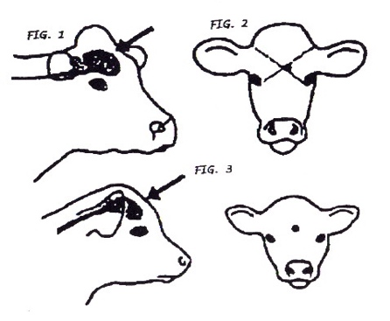
- Animal will be confirmed dead prior to moving:
  - No blink reflex when touch eye e.g., does not blink
  - Widely dilated pupils
  - Does not breathe
  - Cannot raise its head (no righting reflex)
  - Lack of a heartbeat
  - When hanging from loader, tongue hangs limply from mouth and there is no righting reflex (back curving backwards or forwards)
- Feedlot euthanasia equipment is cleaned and maintained by ___________________________.

14. Emergency Salvage Slaughter Protocol
Feedlot Name: ____________________________ Date: ____________________
- Cattle can be emergency salvage slaughtered under the following circumstances:
  - Broken leg
  - Severe AIP
  - Severe lameness (3-legged lame) that is otherwise healthy which cannot be transported live without causing undue distress
  - Calver
  - Bleeding ruptured prolapse that cannot be surgically replaced or amputated
  - Other (describe conditions) _______________________________.
- All cattle must be free of violative drug residues prior to emergency slaughter.
- Mobile butcher will be called to conduct the emergency slaughter at the feedlot, or
- Local butcher will be called for an emergency “shoot and bleed”, or
- Feedlot vet will be called for emergency slaughter at the feedlot (live animal inspection with “shoot and bleed”).
- Non-ambulatory animals will not be dragged or forced to move prior to stunning.
- The animal will be stunned at the feedlot with a secondary kill step as follows:
  - Gun to be used __________________________
    - If the 1st shot doesn’t render the animal insensible immediately (i.e., no blink reflex – no blinking, widely dilated pupils, no breathing, no righting reflex), then animal will be immediately shot again until insensible.
  - Secondary kill step is________________________.
- Correct stunning procedures i.e., correct placement and direction of gun-shot or captive bolt is as per the feedlot’s Euthanasia Protocol.
- CFIA SRM procedures will be followed if animal is moved off site for processing.

15. Antimicrobial Stewardship Policy/Protocol
We at ______________________ feedlot, are committed to antimicrobial stewardship, which is a dynamic process to continually improve our management practices to reduce the need for antimicrobials to preserve their long-term effectiveness for animal and human health and welfare.
Check off (√ ) boxes below that apply to your operation and cross out or delete those lines that do not apply.
- We use good animal husbandry practices to reduce disease risks.
- We house our cattle in feedlot pens, with adequate space and shelter to protect them from inclement weather.
- We have a biosecurity program in place.
- We ensure all cattle have a CCIA and/or USDA EID ear tag for physical and antimicrobial withdrawal individual animal traceability.
- We use licensed vaccines to reduce disease risks and the need for antimicrobials.
- We have a valid veterinary-client-patient relationship with our feedlot veterinarian(s).
- We work with our veterinarian to develop and implement processing and treatment protocols.
- We work with our nutritionist to develop and implement a nutritious feeding program to optimize animal health and train our staff to ensure accurate delivery of in-feed antimicrobials.
- We work with our vet(s) to train our staff to diagnose different diseases and follow our vet’s health protocols.
- We record all vaccine and drug use at processing, reimplant, and treatment, including feed medications.
- We have veterinary prescriptions for all antimicrobial use, including for all Extra-Label Drug Use (ELDU) and feed medications that are prescriptive Medicated Feed Additives (MFAs).
- We only use antimicrobials licensed and approved for cattle by Health Canada – Veterinary Drug Directorate.
- We work with our feedlot veterinarian(s) to monitor, review, and improve our animal health program.
- We work with our nutritionist(s) to monitor, review, and improve our feeding program.
- We dispose of used and expired animal health products and dead animals as per provincial regulations.
- We participate in the national feedlot AMU/AMR Surveillance Program coordinated by CIPARS.
- As new management approaches or alternate animal health products are developed and proven: 1) practical to implement and use, 2) efficacious, and 3) cost effective, we will use them to reduce the amount of antimicrobials we use to prevent, treat, and control infectious diseases in our cattle.
We do all of this to preserve the effectiveness of antimicrobials for future generations and to ensure that the beef industry will continue to have access to efficacious antimicrobials for cattle health and welfare. By using antimicrobials responsibly, we hope to reduce and/or manage the risk of antimicrobial resistance development, and thus, promote animal and human health. As well, we do these practices to ensure global trade in Canadian beef products and ensure food security for the world.
___________________________________ ________________________
Feedlot Manager Name/Signature Date

16. Broken Needle Protocol
Broken needles are a food safety hazard. To reduce the risk of broken needles getting in beef and reaching the consumer, we do the following:
Check off (√ ) and complete boxes below that apply to your operation and cross out or delete those lines that do not apply. Add additional information for your yard as necessary.
To prevent broken or missing needles:
- Restrain animals securely in the chute prior to giving injections.
- Use appropriately sized needles for the animal body size i.e., 16 g x 1” for IM injections, 16 g x ¾” or 5/8” or ½” for SQ injections.
- Give all injections, SQ or IM, in the neck muscles only.
- Change needles every 10-15 head and dispose of them in the sharp’s container.
- Change needles immediately if they become bent or burred or dull.
- After every injection, ensure that the entire needle remains attached to the syringe.

If the needle is not attached to the syringe or it broke off under the bevel, we follow these steps:
- Try to find the missing or broken needle by searching the chute area floor and palpating the animal where the injection was given. The needle either fell on the floor of the chute or is stuck in the animal somewhere.
- If the needle is stuck in the animal, remove it, discard it in the Sharps container, and use a new needle on the syringe.
- If the needle fell on the floor, discard the dirty needle in the Sharps container and put a new needle on the syringe.
- If the broken or missing needle cannot be found on the floor, then it must be assumed that the needle is in the animal.
- Palpate the injection site; try to find and remove the broken needle. Contact the feedlot vet if a broken needle cannot be found or removed.
- Record on the animal’s individual treatment record that it may have a broken needle, record the side of the neck where the injection was, and flag that animal so it will be identified at shipping time that it may have a broken needle in it.
- Prior to shipment:
  - We notify the packer or next owner that this animal may potentially have a broken needle in it. We inform them of the location of the injection site when the broken or missing needle occurred (right or left side of neck), so that this animal can be followed appropriately to ensure the needle does not get into beef for human consumption.
  - We use a mobile butcher or provincial slaughter plant and do a custom beef on the suspect animal for the feedlot’s own meat use.
  - We euthanize the animal.

17. Shipping Protocol and Shipping Record Example
Check off (√ ) and complete boxes below that apply to your operation and cross out or delete those lines that do not apply. Add additional information for your yard as necessary.
- Prior to shipment to slaughter, whether the animal is an emergency slaughter, railer, or regular shipment of a pen/lot to the processing plant, we check all health and feeding records to ensure that the animal(s) have passed all animal health product meat withdrawal periods, including feed medications, to ensure the beef is free of violative drug residues.
- A record is made of who checked the cattle for drug withdrawals prior to shipment to slaughter.
  - When shipping pens or lots of cattle, the animal health computer system’s pen or lot withdrawal report is printed and signed by the person who did the withdrawal check (date, signature). If any animals have not passed their drug meat withdrawal periods, they are removed from the shipment until they are “clean” of drugs. This record is stored in the file with the shipping records for that group of cattle.
  - For shipping individual animals, such as railers or emergency slaughters, the treatment record for the animal is printed and signed by the person who did the withdrawal check (date, signature). Only those animals that have passed the drug meat withdrawal period are shipped. This record is stored in the file with the shipping records for that animal. OR
  - We use the shipping record below, to record drug withdrawal checks prior to shipment to slaughter.
- When exporting fed cattle to the USA for slaughter, we ensure all cattle have met USDA-FDA drug meat withdrawal periods e.g., Excenel®, which is Naxcel® in the USA, has a 4-day meat withdrawal period in the USA versus 0-day meat withdrawal in Canada.
- When an animal or group of cattle is accidentally shipped to slaughter prior to meeting its drug withdrawal periods, if the truck is still in transport, the driver is informed, and the truck turned around and returned to the feedlot to remove the animal(s) from the load. If the animal(s) have already reached the packing plant, the processor is immediately informed so the animal(s) can be condemned so it does not cause a food safety issue in beef. An investigation of this incident is made. Staff are retrained on the shipping protocol to prevent a reoccurrence.

Shipping Record: ___________ (Feedlot Name)
Date | Lot/Pen or Individual Tag ID | # Head Shipped | Destination (Packer) | Lot/Pen ID or Individual Tag ID | Drug Withdrawal Check √ | Broken Needle Check √ | Staff Signature
18. Abortion Protocol
Check off (√ ) and complete boxes below that apply to your operation and cross out or delete those lines that do not apply. Add additional information for your yard as necessary.

We abort incoming heifers at this feedlot to minimize calving complications and reduce welfare concerns with calving and newborn calves in the feedlot, whilst improving economic returns on improved performance and carcass quality of feeding open heifers versus pregnant heifers.

Heifers are aborted according to the following protocol at our feedlot:

- All heifers are aborted as follows:
  - Yearlings: timing of administration: arrival post-arrival: __________
      - Prostaglandin (product, dosage): _________________
      - Steroid (product, dosage): ________________
  - Winter (backgrounded) Calves: arrival post-arrival: ____________
      - Prostaglandin (product, dosage): _________________
      - Steroid (product name, dosage): ________________
  - Fall Placed Calves: arrival post-arrival: _________________
      - Prostaglandin (product, dosage): _________________
      - Steroid (product, dosage): ________________
      - Not aborted since risk of pregnancy low.

OR

- Incoming heifers are examined for pregnancy.
  - Those that are pregnant are re-sold or moved to another facility.
  - Those that are pregnant are identified in health records and treated with the following abortifacient products.
    - Prostaglandin (product, dosage): _________________
    - Steroid (product, dosage): ________________
  - Those aborted are moved into another pen to monitor. If they don’t abort within _____ days after receiving treatment, they are re-examined and if still pregnant, aborted again with _______________________________.

OR

- Incoming heifers are not aborted because pregnant heifers are fed out and calved at the feedlot. Calving heifers are managed as per the Calving Protocol and newborn calves are managed as per the Newborn Calf Protocol.

- Heifers with aborting or calving complications, including dystocia, metritis/retained afterbirth are managed as per the Treatment Protocol for such issues.

19. Biosecurity Protocol and Visitor Log

Check off (√ ) and complete boxes below that apply to your operation and cross out or delete those lines that do not apply. Add additional information for your yard as necessary.

Biosecurity refers to management strategies to prevent disease entry into a production system. These strategies are implemented based on disease risk assessments of what could cause the greatest economic impact or on herd health within a feedlot. Biocontainment refers to strategies within the feedlot to control transmission of disease within an operation. We have implemented a biosecurity protocol and train our staff on this protocol and how to implement the following procedures below to reduce the entry and spread of diseases in the feedlot.
Managing People, Vehicles, Equipment, Tools:
- All of the following can be vectors for disease entry and transmission.
  - People:
    - Visitors must check in with the feedlot office before entering any portion of the feedlot.
      - A record for all feedlot visitors should be kept (see attached Daily Feedlot Visitor Log).
      - This record is kept on file at the feedlot office.
    - Visitors that have had recent exposure to livestock in a foreign country or from other livestock operations (within 48 hours) may pose a threat for introducing disease into the feedlot. These visitors are restricted from animal contact and areas where animals are handled i.e., pens and processing/treat barns.
    - Animal contact by people is restricted to employees and service providers e.g., feedlot veterinarians who regularly care and handle the cattle.
    - If visitors are allowed into animal production areas, they are supplied with clean boots/coveralls, or clean and disinfect their boots and are wearing clean clothing.
    - Employees maintain dedicated footwear for use only at the feedlot. This is important especially if they own livestock at home or have been in contact with livestock on other premises.
    - Hygiene is extremely important.
    - People can spread diseases and parasites to cattle and vise-versa.
    - Plastic gloves are worn by employees while handling, treating, taking rectal temperatures and handling animals to decrease the risk of people getting infected with bacteria/parasites that may cause vomiting and diarrhea.

  - Vehicles:
    - Loaders
      - Dead animal and Manure handling:
        - If possible, loader buckets used to handle feed are not used to handle manure or dead stock.
        - If a secondary bucket is not available, a chain is attached to the bucket to transfer dead animals to the dead box.
        - After contact with manure or dead stock, the loader is cleaned with very hot water +/- Virk on or bleach to remove any bacterial or other contamination that can transmit disease especially if the loader bucket will handle animal feed subsequently.
    - Livestock Trailers
      - We request clean trucks from the relevant trucking companies.
      - We do not allow truckers to clean out livestock trailers at the feedlot. These trailers may contain pathogens from several different premises.
      - If livestock trucks request a place to clean out their livestock trailers, we send them to this area: ___________________________________.
  - Medical Tools:
    - Disposal syringes for treating cattle.
    - Reusable syringes are used for vaccinating cattle. These syringes are cleaned after use with hot water (inside barrel) and disinfectant (type)___________, other than inside the barrel, so as not to leave residue to destroy MLV vaccines. Syringes are cleaned properly to avoid injection site infections and ensure vaccine and drug efficacy.
    - Stomach Tubes/ Bolus Guns:
      - These instruments have direct contact with animal saliva which can transmit diseases, such as Salmonella and BVD virus.
      - Clean the stomach tubes, stomach hoses, pumps and pails, Frick speculum (metal tube) and bolus guns thoroughly with disinfectant soap and water and allow to dry between uses.
      - Store in the treatment room after cleaning.
      - Stomach tubes and bolus guns that cannot be cleaned anymore or have rough edges on them are discarded and new equipment is used.
    - Used needles and scalpel blades:
      - All used needles/scalpel blades are placed in the rigid labeled sharps containers and disposed of as per provincial regulations.

  - Handling Facilities:
    - Treatment/processing chutes and working facilities:
      - Remove all loss manure from the chute and barn working areas after working cattle.
    - Processing and treatment bench”
      - Clean work bench areas at the end of each day.
        - Remove garbage. Syringes, transfer needles and implant guns must be taken to the drug room for cleaning.
        - Return any drugs to the drug room for appropriate storage as per label directions i.e., room temperature or refrigeration.
        - Clean bench countertops with hot water and disinfectant soap.
    - Water bowls in feedlot pens:
      - Drain the water and scrub the sides of the water bowl with a tough bristled scrub brush to remove any organic material. This material or scum on the bottom of the water bowels is where the bacteria live and grow.
      - Water bowls in feeding pens are cleaned __________ (frequency) within the feedlot.
      - Hospital, receiving, and shipping pen water bowls are cleaned ________ (frequency).
      - In the case of a possible disease outbreak (e.g., salmonella), the water bowls are also disinfected with chlorine bleach and scrubbed clean.
  - Premises:
    - Biosecurity signs are posted at the entrance points (roadways) into the feedlot.
      - These signs indicate restricted access and where and who visitors should report to and a phone # to call.
    - Gates and fences protect the feedlot from unplanned entrance of outside animals into the yard or exit of feedlot cattle from the yard.
      - Regular fence maintenance/construction is required to ensure safety to the animals and stop animals from getting out of their pen.
      - Stray animals in the feed animals are returned to their home pen as soon as observed to reduce disease spread and ensure they don’t consume rations that could cause grain overload.
    - Dead Box:
      - Dead animal remains are remove after __________ (days) by _______________ (rendering, biogas company, composted?) according to provincial regulations. This is done to reduce flies/odor and reduce coyotes/foxes/dogs from entering feedlot.
      - Heads, feet and guts from the mobile butcher, and any debris left that rendering/biogas plant did not pick up are disposed of at the feedlot or at the compost site or a landfill (bury under 4 feet of earth as per provincial regulations).
      - Dead fetuses are removed promptly from feedlot pens and placed in the dead box for disposal, burned or composted.
      - Dead animal pick-up and disposal areas are for “feedlot use only”. Neighboring livestock operations or employees may not haul in and dispose of outside dead stock at this feedlot.
    - Pests:
      - Coyotes and other carnivores
        - If coyotes/foxes stick around or frequent the dead box area often, they are shot or trapped as per regulations.
      - Mice
        - Feed mill area and barns: spilled feed is cleaned up to reduce the number of mice, which can transmit disease.
        - Garbage is disposed of regularly.
        - Poison to control mice/rats is only used in areas were pets, horses or cattle cannot be exposed to it and feed or water cannot be contaminated. There is no mouse/rat poison in the feed mills. Live traps (or cats) are used in these areas to catch them.
- Animal Health Practices/Surveillance:
  - Incoming cattle are identified with a CCIA or USDA EID tag.
  - Incoming cattle are identified with a feedlot management tag which is cross-linked to their CCIA or USDA EID tag.
  - Incoming cattle are housed in holding/receiving pens and processed on arrival with vaccines, parasiticides and maybe metaphylactic drugs to reduce disease occurrence and transmission as per the feedlot’s Processing Protocol.
  - Cattle are monitored daily for health, and sick or injured animals are treated as per the feedlot’s Treatment Protocol.
  - Animal health protocols, including vaccinations, parasiticide use, and treatment protocols, are followed as per instructions of the feedlot veterinarian(s).
  - All processing and treatment events and feed medications are recorded by individual animal if individually treated and/or by group (lot/pen) if group treated.
  - Sick cattle, if treated with long-acting drugs, are returned to their home pen immediately to reduce disease transmission within sick pens.
  - Sick cattle requiring daily treatments and/or rest are housed in speciality hospital pens and checked daily as per the Treatment Protocol.
  - If sick or injured cattle do not respond to initial treatment, they are repulled and retreated or managed as “chronic” or “railers” or “emergency slaughters as per the Treatment Protocol, Chronic Pen Protocol, Railer Protocol or Emergency Slaughter Protocol.
  - Chronic, buller, and rail pens are checked daily to check health status of the animals, ensure pens are not overcrowded, and that there is sufficient bedding and good feed and water available for all animals. Any animals in distress are humanely euthanized or salvage slaughtered as per the Euthanasia and Emergency Salvage Slaughter Protocols.
  - Animals not responding to treatment are either sold, if fit for human consumption, or euthanized if unfit for human consumption, as per the Euthanasia Protocol and Railer or Salvage Slaughter Protocols.
  - Unusual cases or high rates of disease are reported to the feedlot veterinarian(s) as soon as possible. For foreign animal disease control, refer to the Emergency Response Plan.
  - All animal health products, including feed medications, are used, stored, and disposed as recommended by the manufacturer’s labels and/or veterinary prescriptions.
- Water and Feed control and monitoring:
    - Only Canadian government approved feed additives are used.
    - Feed premixes and/or supplements are purchased from HAACP approved commercial feed mills.
    - Feed additives, if using micro-machines, are purchased from reputable licensed suppliers.
    - Incoming loads of feed ingredients, such as grain and supplements, are inspected for contaminants (e.g., bird poop, ergot, mold, other feed grains not purchased), and rejected if the feed contains unacceptable levels of these substances.
    - Old feed and manure are removed from feed bunks before fresh feed is added.
    - Water for cattle is testing at least annually for TDS (total dissolved solids), coliforms, and mineral levels such as sulfur (if ground water is used), and corrective actions are taken if issues are found.

Feedlot Visitor Log: _____________ (Feedlot Name)
Date | Name | Reason or Person Visiting | Time In | Time out | Signature

20. Cattle Health Product Management Protocol
Check off (√ ) and complete boxes below that apply to your operation and cross out or delete those lines that do not apply. Add additional information for your yard as necessary.
Receiving
- Only animal health products approved by HC-VDD, CFIA or PMRA are purchased and used. Approved exceptions are animal health products imported under OUI regulations from a government recognized by Health Canada-Veterinary Drug Directorate (HC-VDD), such as USDA-FDA, or those imported under an Emergency Drug Release or Experimental Studies Certificate from HC-VDD, research permit from CFIA-Biologics Division, or special permit from PMRA through the provincial government.
- A copy of the purchase/packing slip of all animal health products received is given to feedlot administration staff.
- If the animal health software system is computerized and allows entry of all incoming products, all products received are recorded in the system.
- A copy of each animal health products manufacturer’s label is kept on file in a binder or access is readily available from the Compendium of Veterinary Products (free app to download on iPhone or Android phones called “CVP”).
- MSDS sheets are kept on file or readily accessible for all animal health products used.

Storage
- After ordering and receiving animal health products viz. vaccines, parasiticides, implants, antimicrobials and other drugs, each product is stored in the fridge or at room temperature as per the manufacturer’s label recommendations.
- Animal health products are rotated so that the oldest products e.g., those with the shortest expiry dates, are used first.
- Expired animal health products are disposed as per provincial regulations.

Administration
- All animal health products are administered as per label directions and/or veterinary prescriptions.
- When product labels allow either SQ or IM administration, the SQ route is used where feasible to reduce injection site lesions resulting in trim of meat at slaughter and tough beef.
- All IM/SQ/IV animal health products are administered in the neck area only, to reduce injection site lesions, associated meat trim, and “tough beef” in valuable cuts of meat.
- Syringes are checked to ensure they are set at the proper dosage for the product. Auto-dozer syringes are used if available, operational, and safe to use with the specific animal health product.
- Cattle are weighed on a scale for accurate dosing of products where product dosage is based on body weight; else, body weight is estimated as best as possible when no chute scale is available.
- Disposable gloves are used when administering animal health products to ensure worker safety.
- Pregnant staff do not administer prostaglandins e.g., Lutalyze, Estrumate, Bioestrovet, unless specific care is taken to reduce human safety risks.

Inventory Management
- If the animal health management system is computerized and tracks inventory usage, drug inventory is physically counted __________ (frequency e.g., monthly).
- Expiry dates are checked when inventory is counted and those products that have expired are disposed of as per provincial regulations.
- The physical inventory of animal health products is reconciled to the recorded product (commodity) usage from processing/treatment/feed records.
- When the recorded product usage and physical inventory counts of product do not match within reasonable limits for that product e.g., accounting for wastage, the discrepancy is investigated, and problem areas are corrected.
  - Inventory reconciliation problems may arise from counting or data recording errors, broken bottles, failure to use products as per protocols or label directions (e.g., larger or smaller volumes used than recorded or forgetting to give a product), theft of product.
- If inventory management issues are repeatedly found, inventory reconciliation is done more frequently to resolve problems.

21. Calving Management Protocol

How to tell when a heifer/cow is close to calving:
Several signs will be present when feedlot heifers or cows are close to calving. Not all heifers/cows will exhibit all signs, but some should be present in heavily pregnant heifers/cows.
- Udder will fill up and become more prominent (see below).
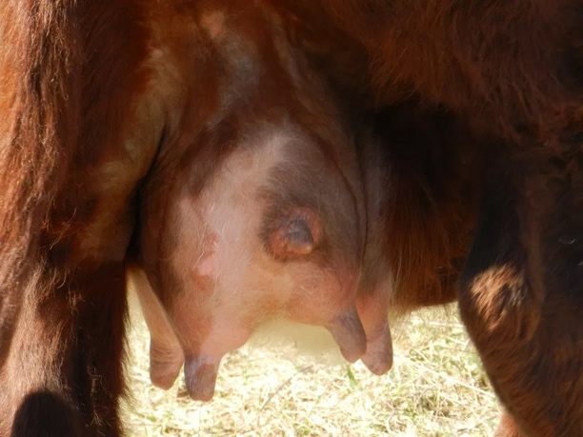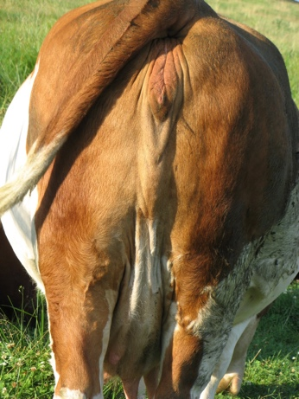
- The vulva will “spring”- becomes more prominent and floppier (see above).
- Lower abdomen of heifer will be round and heavy, especially on the right side.
- Pelvic ligaments will relax, and tail head will be more prominent.
- Animals will “nest”- separate themselves from herd, look for cozy spots to deliver calf, if other calves in pen may try to mother them.
They may need to be assessed as to whether they can be shipped to slaughter ASAP (prior to starting calving) if feasible/practical, or whether they need to be put in a hospital pen away from sick animals and monitored closely while calving. Advise the feedlot foreman immediately, who will decide if these animals can be shipped to slaughter ASAP or if they will be calved out on the feedlot. Note: it is illegal under CFIA transport regulations to ship a calving heifer other than for veterinary assistance. Any calving heifers sent to emergency slaughter must be “shoot and bleeds” and CFIA SRM policies must be followed for transport of such animals to a provincial meat processing plant.
Signs of normal labor:
A normal labor can be divided into three stages and knowing these stages will help to determine if the heifer needs some assistance to deliver the calf.
Duration | Progress | Clinical Signs in Heifer
Stage 1 – lasts 2 to 6 hours (can be longer in heifers) | Calf moves into the birth canal. The cervix dilates and the water bag from the first sac breaks. The second water sac moves through the birth canal. Stage 1 ends with delivery of waterbag. | Restless, may kick into its side, tail wringing, isolation from other animals, gets up and down frequently looking around for something, bagged up, tail head rises, swollen vulva lips.
Stage 2 – last ½ to 4 hours | Rupture of the second water sac. Dilation of the birth canal. Uterine contraction and calf delivery (around 2 hours after you see the water sac, longer in heifers particularly if you disturb them during calving). | You see the water sac or a long string because the sac has ruptured, feet appear (if normal presentation). Abdominal contractions are visible. Animal often lays down to push.
Stage 3 – lasts less than 12 hours | Separation of placenta, uterine contractions. | You see the afterbirth from the vulvar opening. Uterine fluids are pushed out.

When to assist:
Feedlot heifers will often require more assistance to calve than regular replacement heifers due to several reasons, including poor pelvic anatomy, smaller size (in the case of young animals aborted on arrival), large amounts of fat in the pelvis etc. Remember dystocia (calving difficulty) can occur both during full term normal labor and after induced abortion post-arrival.
Animals noted to be calving should be monitored closely and immediately assisted if any of the following occur:
- Animal fails to progress from stage 1 labor (restless, delivery of water bag) to stage 2 (obvious contractions, delivery of feet) within 4-6 hours.
- Animal fails to deliver calf within 2 hours of waterbag appearing.
- Animal is found in the morning pen checking to be calving and the calf is partially out and dead (assistance is required immediately as you don’t know how long she’s been in labor).
- Heifer is found to be calving close to the end of the day when staff is about to go home and shut the gates for the night (DO NOT leave until calf has been delivered or someone is returning to monitor in a couple of hours).
- Heifer appears to be in distress (i.e., unable to get up, weak, vocalizing excessively etc.).
- Calf is backwards - when feet are visible the declaws are pointing up (in normal forwards delivery dewclaws will point down). See picture below of backwards feet:
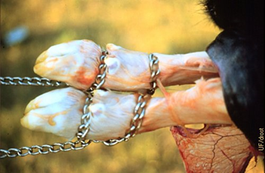
Backwards presentation – dewclaws pointing up. Note proper placement of calving chains.

Calving Equipment
- Clean pail with warm water
- Plenty of lubricant (J-lube or PolyLube) (you cannot have enough lubrication!)
- Clean calving chains and calving handles
- Disinfectant such as Povidone Scrub (iodine scrub soap)
- Plastic sleeves and gloves
- Calf puller with calving chains and calving handles
- Halter
- Calving chute with side-release gate, nonslip flooring
- Maternity pen with clean, ample, dry bedding, sufficient size so heifer doesn’t lay on newborn calf, water and feed for heifer
How to assist:
- Put heifer into calving chute/maternity pen, ensure there is clean straw in chute and no ice to prevent slipping and keep newborn calf clean.
- Put on clean OB gloves and waterproof clothing (if available).
- Clean heifer’s vulva with iodine or hibitane soap and tie tail to the side or ask assistant to hold it.
- Determine calf’s presentation (see examples below of different presentations). Correct any malpresentations if possible, as instructed below. If unable to correct, please call veterinarian immediately.
- Place calving chains on legs:
- The preferred placement of the obstetrical chain is with the loop below (distal to) the dew claws and one loop above the fetlock. The hitch should come off the foot in the same location on both feet. When the chain is relaxed the loops closest to the foot sometimes falls off, if this happens, replace it. When only a single loop is placed, too much force is placed on the metacarpal or metatarsal bone, which can lead to fractures, or if calf is dead and rotten, foot may come off and then very hard to pull out.
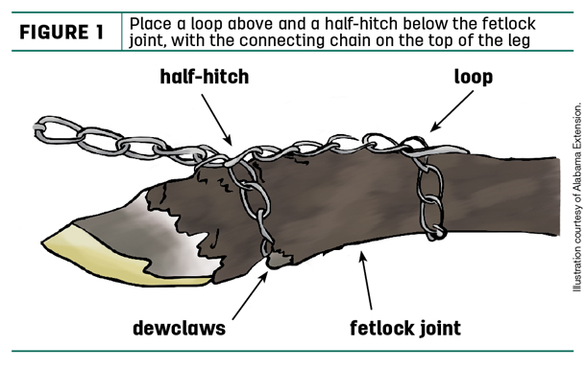

- Pull calf
  - Once calving chains are placed, hook calving handles onto chains.
  - If calf feels dry administer plenty of calving lubricant (e.g., J Lub, Poly Lub) onto calf and into heifer’s vulva before pulling.
  - With your assistant pull calf straight out, timing your pulls with the heifer’s contractions. Once calf’s head is out, you can pull down towards her feet at a 45° angle until calf is out.
  - If unable to pull by hand (i.e., by yourself, both you and your assistant are small, calf is large, etc.) a calf jack can be used.
    - Note: Calf pullers, or calf jacks, are mechanical devices used to deliver calves when sufficient human help is not available. They are inherently dangerous to the calf and the heifer because of the excessive force they can exert. They should only be used when it has first been determined that 1) there is sufficient room in the birth canal to deliver the calf; 2) the calf is lined up correctly e.g., 2 front feet and a head or 2 back feet and a tail all belonging to the same calf (i.e., in cases of twins); and 3) there is ample lubrication. The force generated by two adults is usually enough to pull a calf, therefore a calf puller is not required in every situation.
    - How to use a calf jack: Once chain(s) are applied to both feet, place breech (butt brace) on heifer’s hips below vulva and place strap over the top of her hips. Connect the rod to the brace with the jack at the end closest to the heifer. Connect the chain(s) to the hook on the jack. Crank jack down until chain are tight, wait until heifer pushes. When heifer pushes, push jack handle down toward the ground, release pressure when she stops pushing. Crank jack again to take up slack. Repeat until calf is delivered. If calf is alive and pull takes more than 2 minutes; stop occasionally and release tension on jack to allow calf to breathe. *** Note: if calf is backwards pull straight out with jack and crank continuously, do not stop for any reason once you start.
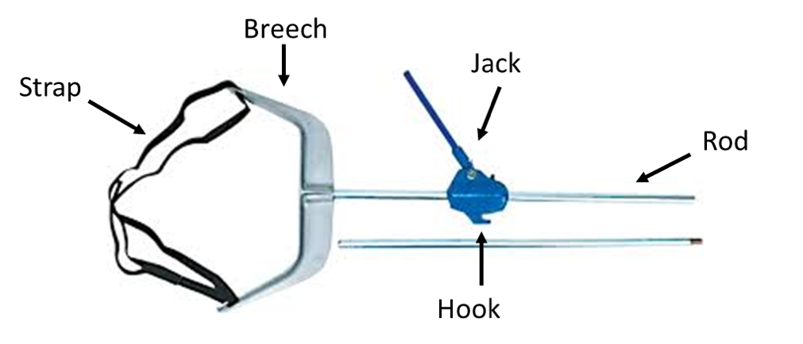

- Once calf is delivered ensure the calf can breathe. If necessary, stimulate breathing by tickling calf’s nose with clean straw. Cold water can also be splashed on calf to help stimulate breathing. Place in recovery position by setting it upright on its chest with all four legs extended out to the front (see picture below). DO NOT hang it over a fence/wheelbarrow etc. this makes it harder for the calf to expand its lungs and breathe.
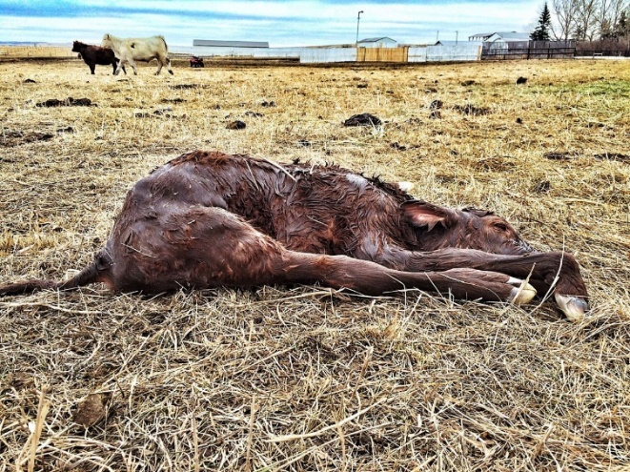
- Check heifer- clean gloves and perform vaginal exam to check for vaginal/uterine tears (fingers will fall into a “hole”) and for a twin/triplet. If another calf is found, repeat steps 3-8. Do not assume there is only one calf even if the calf is big. If a vaginal tear is found call veterinarian for assistance. If uterine tear is found, consider emergency slaughter if possible or humanely euthanize.

- Leave heifer and calf alone to bond. If cold outside or heifer rejects calf, help dry calf off by rubbing it dry with clean towels/straw, so it doesn’t die of hypothermia.

- After 2 hours, if calf has not been seen sucking the heifer, please assist it to nurse or tube with colostrum. Treat the heifer as per feedlot treatment protocol for calving heifers. See Newborn Calf Management Protocol for how to manage newborn calf.
Normal presentation, posture and position:
- Cervix is fully dilated
- Head and both legs are in the birth canal
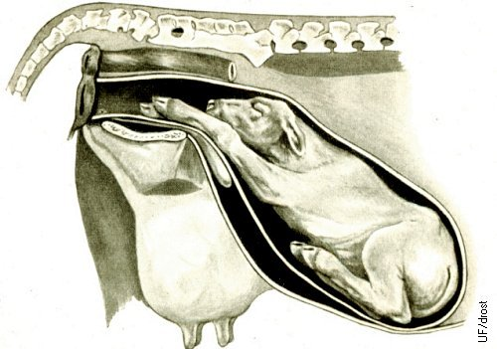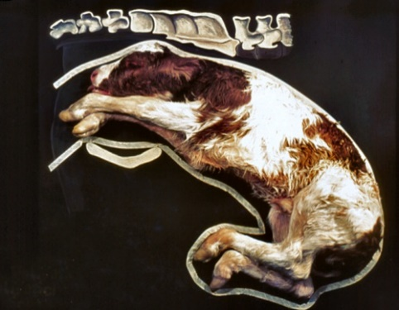

ONLY pull a calf if you have two legs and the head in the birth canal. If the head is back it needs to be corrected before you pull. Otherwise, you will be unable to pull out the calf successfully and you will cause major damage of the uterus (possible tears) or to the calf (it can die because of the pressure to his neck and decreased oxygen supply to his brain) or you will break its front legs.
Before pulling, ensure there is enough room in the pelvis for the calf to be delivered. You should be able to fit a hand between the calf’s head and the heifer’s pelvis. If you are unable to do this, the calf is likely too big. Please call for veterinary assistance as a C-Section or fetotomy (if calf dead) may be needed. Likewise, if the front legs are crossing over each other the calf is likely too big to be delivered vaginally and veterinary assistance will be required. Once you have determined the calf is too big, stop pulling, allow the heifer to rest and wait for the veterinarian to arrive.
Once you have determined the calf can be delivered vaginally, put the chains on the front legs, above and below the fetlock as described above, and then pull the calf straight out until the head is out of the birth canal. Once the head is out of the birth canal, pull down towards the heifer’s feet. If someone is at the tail head of the heifer, put your arms between the calf’s front legs and try to rotate the calf sideways as you pull the ribs and hips out to prevent hip lock. Pull on the calf when the heifer pushes, relax and rest allowing the calf to breathe between her contractions. Ensure the placenta (afterbirth) is not covering the head and nostrils of the calf; else it can’t breathe.
Normal backwards position with both legs extended
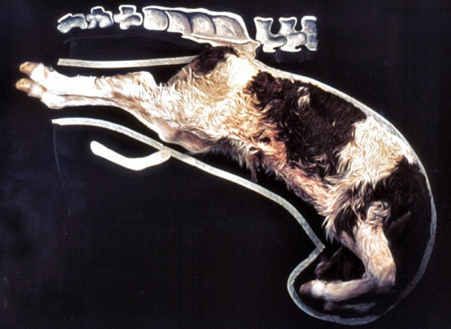
If you have this backward position and posture, the calf can be delivered if there is enough space in the pelvic canal. In some cases, it helps to rotate the calf, so its hip is oblique to the heifer’s hip which will prevent hip lock.
Pull the calf straight out and continue to pull the calf out until it is out (don’t wait for heifer to push because once you pinch the umbilical cord, the calf cannot breathe, so you must get it out quickly. Do not pull downward as you will hook the calf’s ribs on the heifer’s pelvis.). Use calf jack to help pull quicker if both you and your assistant(s) are small. If you are unsure if you have enough space to deliver the calf, please give call the vet to assist.
The following images show a few examples how to correct malpresentations. For further information and images please visit the Drost project. www.drostproject.org; https://visgar.vetmed.ufl.edu/en_bovrep/calving-problems/calving-problems.html
Please call the vet if you have any questions regarding the presentation corrections or if you are unable to correct these postures within 15-20 minutes. If they are not corrected, you will be unable to deliver the calf and you should not attempt to pull the calf out because you will hurt the calf and the heifer. The goal is to have a live newborn calf and live feedlot heifer that can be finished and slaughtered.

Front leg back at the fetlock
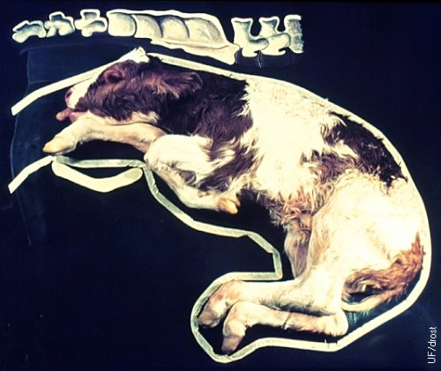

If you have enough space to work within the uterus, grab the “cannon”- bone and direct the fetlock upwards and sideways. At the same time turn the hoof inwards and straighten the leg out. Try and cup your hand over the foot once possible to avoid ripping the uterus. | 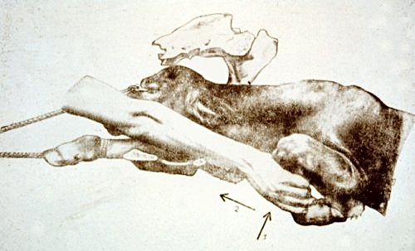
If only the fetlock is retained: apply some traction to the limb (calving rope or chain) and push the fetlock upwards and sideways. Try and cup your hand over the foot once possible to avoid ripping the uterus. | 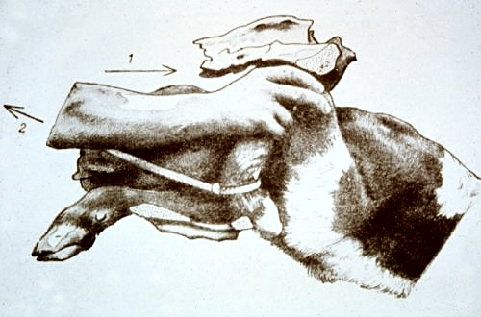

Front leg retained at the shoulder
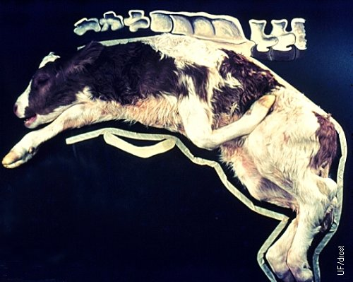
First push the calf gently further back into the uterus to create more room for your maneuver. | 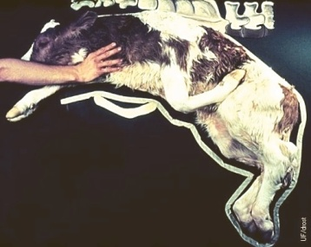
Push the calf further back into the uterus until you can feel the fetlock and foot of the calf. | 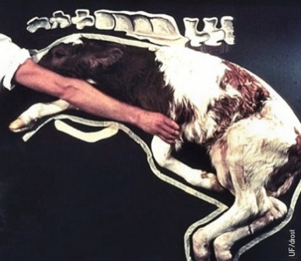
Grasp the leg on its top part and the fetlock will twist inwards. | 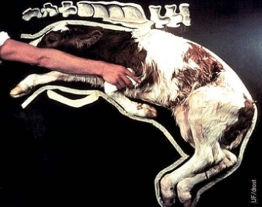
Then lift the leg further up and rotate it inwards. You should be able to grasp the fetlock and hoof now. | 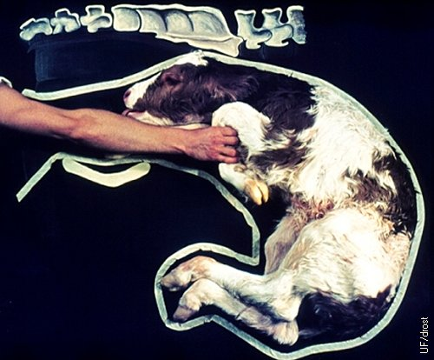
Grasp the “cannon”-bone firmly and push it upwards and to the side to guide the pastern inwards. | 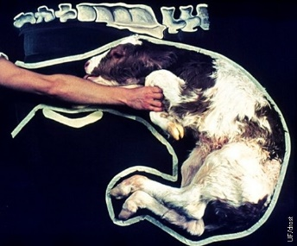
While the metacarpus is grasped firmly, the carpus is twisted upwards and laterally to lift the claw above the level of the pubic brim.  It is important to protect the tight ventral wall of the uterus just below the pubic brim against the pointed claw by cupping the hand around the hooves. | 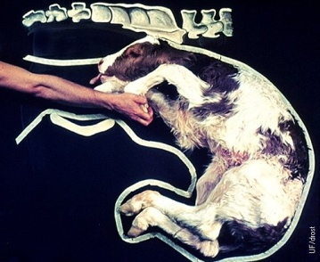

Back Leg retained at the hock
The calf is being repelled (pushed back) into the uterus to make room for maneuvering the leg into extension. | 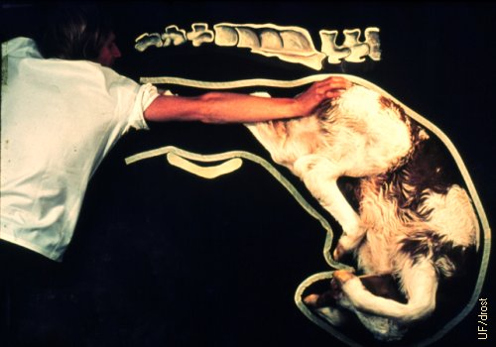
 | 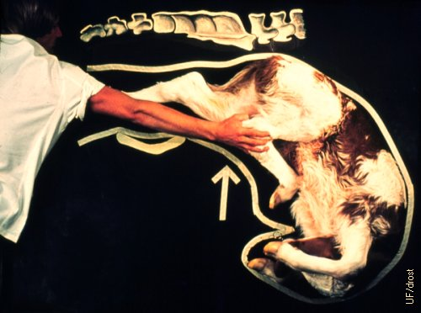
The hock is pushed upwards and outwards to make the hoof accessible. | 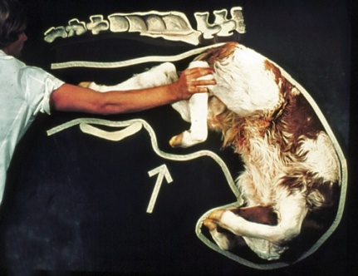
Attach a chain to the foot. Then apply pressure on the chain while the hock is pushed forward and outwards this will extend the leg. | 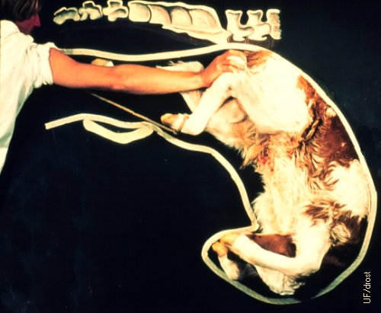
Protect the uterine wall against the pointed claws by cupping them with the hand. | 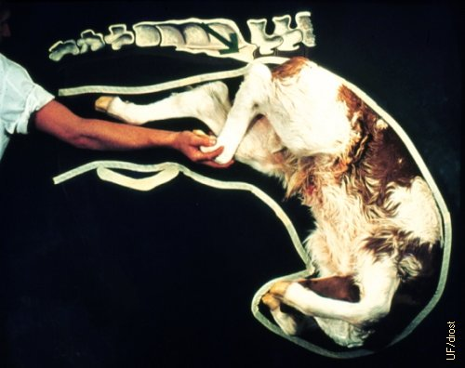
Both legs are now extended, reducing the diameter of the calf. The next step is to measure the relative size of the calf and the amount of space in the pelvic cavity to see if you can pull the calf. | 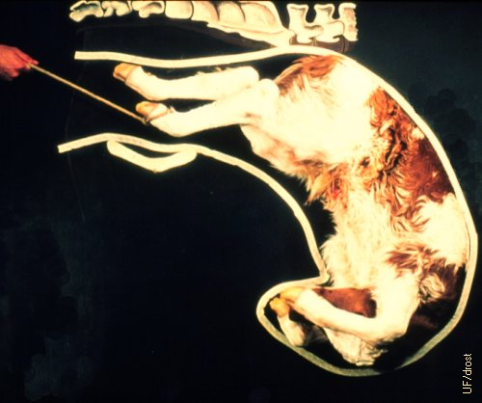

Head is back
This abnormal posture is frequently the result of a weak fetus or dead fetus that fails to participate in the delivery process by keeping its head and neck extended.  Also occurs in feedlot heifers if the calf is too big to be delivered unassisted. | 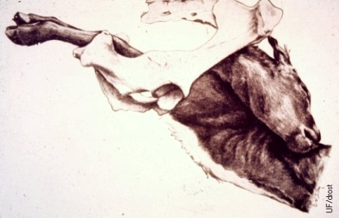
Gently push both front feet back into the birth canal and try to grab with your hand the mouth of the calf and pull it over the pelvic rim. It’s important to cover the teeth with your hand otherwise the sharp edges of the teeth lead to tearing of the uterus. If you have a dead calf and you cannot reposition the head a fetotomy may be required, please call a veterinarian for guidance/assistance. Do not pull a calf when you cannot get the head into the birth canal.

True Breech
Backwards presentation with both legs frontwards and retained at the hip. | 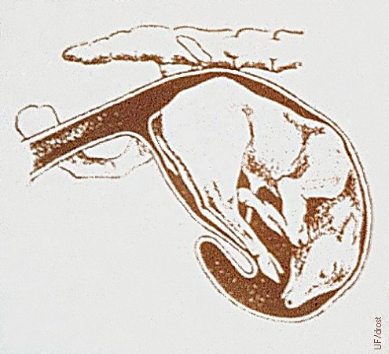
The first step in the correction of a true breech is to repel (push) the fetus anteriorly (forwards) and upwards, and to retrieve a hock. | 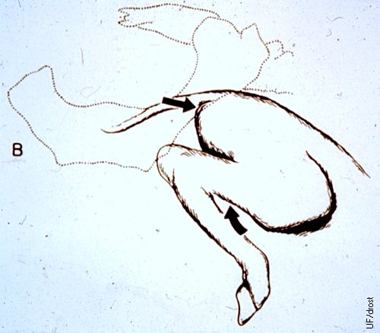
The second maneuver is to push the hock laterally and forwards which aids in bringing the fetlock medially. | 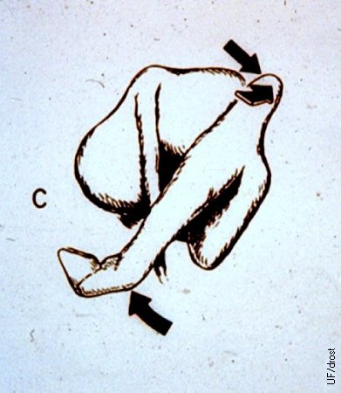
Final extension of the first leg. The procedure is repeated for the second leg, which should be relatively easier because there is more room to maneuver. Now you have a backwards calf. Check to ensure there is enough room in the birth canal to pull the calf. | 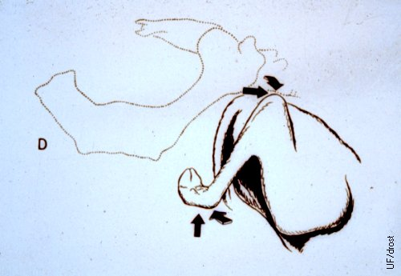

Upside down calf
There are two different ways a calf can become upside down in the uterus, a uterine torsion and a true upside-down calf.
Uterine torsion:  The uterus flips on itself often resulting in the calf being upside down. When feeling vaginally it may feel like your hand is being twisted in one direction or the other instead of going straight in, it may also feel like the cervix is not fully dilated. The uterus will also feel tight. Determine which way the calf is flipped and then attempt to flip it back the opposite direction by grabbing its head and rocking it until you have enough momentum to flip it completely. Once corrected, pull calf normally. If unable to correct a c-section will be required. | 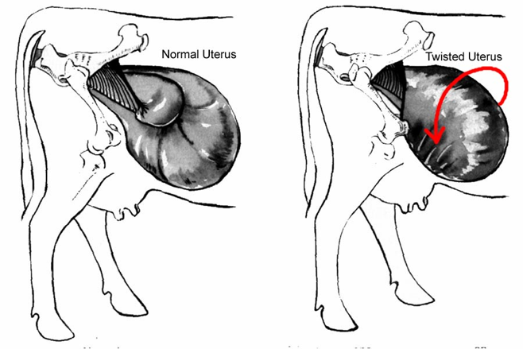
True upside-down calf:
This presentation can be differentiated from a torsion by the loose cervix and uterus. Begin by locating legs and pulling them out of vagina. Cross legs and place pressure on shoulder of calf to twist it back right side up while guiding head with other hand. Once corrected pull normally.

Incomplete Cervical Dilation
- Signs: Cow will appear to be in labor (pushing, fetal membranes visible etc.) but will not make progress. On vaginal examination your will feel like it runs into a wall of tissue with a small opening or a tight band of tissue will be felt around the calf.
- Correction: If cow has just started calving leave her alone and recheck in an hour. If cow has been calving for some time, apply manual pressure with hands to gentle stretch cervix. If unable to fully open cervix, call for veterinarian.

22. Newborn Calf Management Protocol
Newborn calves have a difficult time to regulate their body temperature and easily get hyperthermic (too warm) or hypothermic (too cold). Bring a wet newborn calf into the barn if the outside temperature is very cold and the mother is not taking care of it. If still wet, dry it off with a towel or dry straw. If hypothermic, add a heat lamp over top of the calf and ensure it is well bedded on dry straw or bring it into a heated room. Warm it up by feeding warm colostrum, and if needed, covering it with blankets/sheets (including it is laying on a warm surface e.g., blanket). A warm (not hot!) water bath can be used if you have a big enough container to fit the calf in, keeping the head above water at all times (e.g., large Rubbermaid tub, laundry sink).
The first milk (colostrum) is very important for the newborn calf. It is nutritious and contains vitamins, minerals, and antibodies (protective proteins) important for the calf to be able to fight infections. A calf is born without any protection and it will take several weeks to be able to mount an adequate immune response to fight infections. Therefore, the colostrum is of major importance to calf survivability.

Colostrum (1st Milk) Management:
- Ensure calf receives at least 1 Liter of colostrum no later than 4-6 hours after birth, assist calf to suck off heifer if possible or tube feed if it cannot suck (i.e., weak calf, swollen tongue etc.). Calf should receive a minimum of 10% of its body weight in colostrum within 18 hours of birth (Ideally 2-3 Liters within the first 12 hours of life).
- If the cow has insufficient colostrum (i.e., twins, heifers with small udders, abandoned calves, mastitis, cows who are sick etc.) the calf must be supplemented from another source
  - 1st option: Milk colostrum that you got from healthy, heavy producing cows from a beef herd. Freeze the colostrum in 1 Liter Ziploc bags for later use. Thaw in warm (not boiling) water bath and feed via stomach tube or nipple bottle. DO NOT USE MICROWAVE TO THAW since it will destroy antibodies (protective proteins that calf must get from colostrum). Calves will need at least 2-3 bags within first 12 hours of life (10% of body weight e.g., 45 kg calf needs 4.5 L colostrum). This is the best option as calves will get antibodies to bacterial/viral pathogens found on the farm.
  - 2nd Option: Use a high-quality powdered colostrum replacer (e.g., Head-Start Colostrum) with at least 60 grams/package IgG. Mix and feed according to label directions and feed via bottle or stomach tube. Calves will need at least 2 packages (3 packages if using lower IgG content replacer) within first 12 hours of life to have sufficient immunity if they are not getting any colostrum from dam.
  - Do not use dairy colostrum or colostrum from other herds as the quality can be unknown. A number of diseases including Johne’s can be brought into a herd from infected colostrum.
- The navel of the newborn calf is a major source for entrance of bacteria causing navel infections, septicemia or joint infections (polyarthritis). Therefore, it is recommended to spray the navel with an iodine-based solution (Providine Solution) a couple of times after it is born especially if it is dirty. Please ensure that the navel dries up within a couple days. If the navel continues to bleed after delivery, you can tie the umbilical cord with umbilical tape (i.e., rectal prolapsed tape), but please remove it after 24 hours because if the tape is left too long around the navel, it can lead to inflammation and infection of the navel. Do not “touch” the navel with your hands as they are dirty and can increase the risk of navel infections.
- The feedlot is one of the worst environments for a calf because a high dose of environmental bugs. Therefore, you need to remove the calf as quick as possible from the feedlot, unless you are set up with maternity pens to manage calving heifers and newborn calves. Please contact the feedlot owner as to what they want to do with newborn calves e.g., sell at local auction or allow feedlot staff to raise. Note: newborn calves cannot be sold at the local auction until they are at least 8 days old and the navel is dry. Please keep calf in a clean, dry, well bedded pen away from sick animals until a decision is made about what to do with it.
- If the calf was pulled and the limb or other parts of its body are broken, please contact veterinarian to determine if fracture can be casted or if the calf needs to be humanely euthanized.
Newborn Procedures:
- Move the newborn calf and its dam from the home feedlot pen into a separate little pen with dry straw bedding.
- Keep the calf warm if it is cold.
- Give colostrum (first milk) to the calf within the first 4-6 hours of life (10-15% of its body weight over the first 18 hours).
- Spray navel with Providine Iodine.
- Remove calf as quick as possible from the feedlot if it will not be raised there as the feedlot is not a healthy environment for newborn calves.
- Euthanize calf humanely if the calf suffers from major injuries (e.g., open fracture), is sick, or too premature to survive. Contact feedlot veterinarian on best method to euthanize newborn calves.
Feeding and Management of Calves
If the calf is being kept, feedlot staff must be prepared to put considerable effort into its daily care, especially if the calf is orphaned/abandoned.
- Ensure adequate colostrum intake (minimum of 10% body weight within first 12-18 hours of life). If heifer does not have enough colostrum, supplement with commercial colostrum e.g., Head Start Colostrum, as per label directions. Calf should be fed 3-4 times in its first day of life.
- Ensure the cow has enough milk to feed the calf (10% of body weight daily e.g., 50 kg calf needs 5 liters of milk daily). Signs that heifer has insufficient milk include the calf sucking on the udder for long periods of time frequently, frequently bunting the dam’s udder, poor growth of the calf, lethargy or sleepy calf (not playful), bawling calf, etc.
- If the heifer has insufficient milk, supplement the calf with a good calf milk replacer as needed. Ensure the milk replacer has “milk protein” in it and not “soy protein” in it as calf can’t absorb soy protein at this age.
- For orphaned newborn calves, start calf on good quality bovine milk replacer once the calf is one day old, after it received sufficient colostrum on Day 1. Purchase high quality calf starter milk replacer (i.e., Brown’s Calf Starter or Wet Nurse Red or Green Tag or Grober CalfPro) and feed according to package directions. The calf should receive approximately 10% of its body weight in milk each day, spread over 2-3 feedings daily. The calf must be fed at least three times daily during cold weather (less than 0°C). Try to space feedings as evenly apart as possible.
  - Store milk replacer in a clean dry location in a sealed container (i.e., Rubbermaid tub) to minimize contamination and ensure palatability
  - Mix milk replacer with warm (38°C) water using a bowl and whisk until all clumps are gone. Feed right away while milk is still warm (should feel warm on your wrist but not hot or cool)
- At one week of age, offer a high-quality calf starter ration. Good young calf rations are available at many feed stores or feed mills. Begin by offering no more than 0.5 lb daily. Throw out leftover or poor-quality ration and replace with new feed daily.
- Once the calf is two weeks old, ensure that some good quality grass hay is freely accessible to the calf, as many small calves will not eat silage. Also offer free choice clean water ad libitum and replace daily.
- Once calf is three weeks of age, it can be switched to a calf grower milk replacer (i.e., Brown’s Calf Grower or Wet Nurse Orange Tag). Continue to feed according to label directions.
- The calf can be weaned from the milk bottle when it is 2.5-3 months old and is eating forage/ calf pellets well. The calf should be eating about 1 lb of calf starter pellets when it is weaned.
- After weaning, increase the calf starter pellets by 1 lb each week until it is 4-5 months old. Continue to offer good quality grass hay free choice. Ensure the calf can reach water and that a bucket is filled with clean fresh water several times daily or provided ad libitum, as it is highly unlikely that these small calves can reach and drink water from the water bowls in the feedlot.
- Keep cow-calf pairs separate in a clean dry hospital/ receiving pen away from sick animals. Keep orphaned newborn calves in a barn or calf hutch or small pen with ample dry bedding and protection from inclement weather and predators such as coyotes.
- Contact veterinarian to see what mineral e.g., selenium or vitamin (vitamin ADE) injections to give newborn calf shortly after birth. Give the calf a CCIA ear tag in its ear.
- Contact veterinarian what respiratory and clostridial vaccinations to give the calf and at what age and when to booster vaccinations.
- Once the calf is 4-5 months old (approximately 400 to 500 lbs), determine if the calf will be processed into the feedlot as a feeder calf and follow feedlot protocols for such aged calves.

23. Carcass Disposal Protocol
Check off (√ ) and complete boxes below that apply to your operation and cross out or delete those lines that do not apply. Add additional information for your yard as necessary.
- We dispose of dead animals as per provincial regulations for dead animal disposal. This is generally within ______ hours.

- Prior to removal of animals to the dead box, whether recently euthanized or not, we ensure the animal is dead by checking blinking responses, size of pupil (should be widely dilated), breathing, and movement (as per the Euthanasia Protocol). This check is done to ensure there are no live animals in the dead box. If unsure, we contact our veterinarian.

- Dead animals are removed from their pen to the dead box within 24 hours.

- We dispose of dead carcasses the following way(s):
- Rendering pick-up
- Bio-Gas Plant pick-up
- Composting at feedlot
- Burial
- Other (describe): _________________________________________________

- If mobile butchering is used occasionally and butcher leaves behind by-products, such as the head, feet, and guts, we dispose of them as follows:
- Burial
- Other (describe): __________________________________________________

- We pick up dead baby calves or aborted fetuses from feedlot pens and dispose of them by:
- Burial
- Other (describe): __________________________________________________

- We do not dispose of SRM (specified risk materials: guts, brain, spinal cord) in bedding packs of feedlot pens as this is prohibited by federal regulations for BSE control.

24. Chronic Pen and Railer Protocol
Check off (√ ) and complete boxes below that apply to your operation and cross out or delete those lines that do not apply. Add additional information for your yard as necessary.

- Animals that have received all treatments as per the veterinarian’s Treatment Protocol but have not recovered and cannot compete in their home feeding pen are moved to a chronic or convalescent or railer pen for recovery.
- Railers are any animal pulled from their home feeding pen and shipped to slaughter prior to the shipment of their entire pen. This can include animals that are injured, foundered, early heart failures, early AIPs, or other conditions, including animals with chronic arthritis, that are salvageable as per the Salvage Slaughter Protocol.
- Pens are checked daily.
- Any chronic or railer animals in distress or with no hope of recovery or salvage value are euthanized immediately as per the Euthanasia Protocol.
- Chronic and/or railer animals are railed in a timely manner when suitable for human consumption as per the Salvage Slaughter Protocol and Shipping Protocol (drug withdrawal check is confirmed prior to shipment).
- Chronic and railer pens are well bedded, as needed, because these animals are compromised.
- Pens have wind break fences, natural barriers, or barns to protect these compromised animals from inclement weather.
- There is ample space for all animals in the pen to lie down and move around easily.
- Water is provided ad libitum.
- Water bowls are cleaned at least once weekly.
- Feed is provided at least once daily.
- Feed bunk is kept fresh and moldy feed and debris is cleaned out of the bunks regularly.

